


Project Initialization and Planning Phase
Date | 28 January 2026
Team ID | LTVIP2026TMIDS52507
Project Name | IntelliSQL: Intelligent SQL Querying with  LLMs Using Gemini Pro
Maximum Marks | 3 Marks
Define Problem Statements (Customer Problem Statement Template):
In today’s data-driven environment, organizations and individuals increasingly rely on databases to store and retrieve critical information. However, interacting with relational databases typically requires strong knowledge of Structured Query Language (SQL), which poses a significant challenge for non-technical users such as students, analysts, managers, and domain experts. Even for experienced users, writing complex SQL queries can be time-consuming and error-prone.
Traditional database querying tools lack intelligent assistance and contextual understanding, forcing users to manually translate their information needs into syntactically correct SQL queries. These limitations often result in incorrect queries, reduced productivity, and inefficiencies in data access and analysis.
To overcome these challenges, there is a need for an intelligent, user-friendly system that enables users to interact with databases using natural language. IntelliSQL addresses this gap by leveraging advanced Large Language Models (LLMs), specifically Gemini Pro, to automatically convert natural language queries into accurate SQL statements.

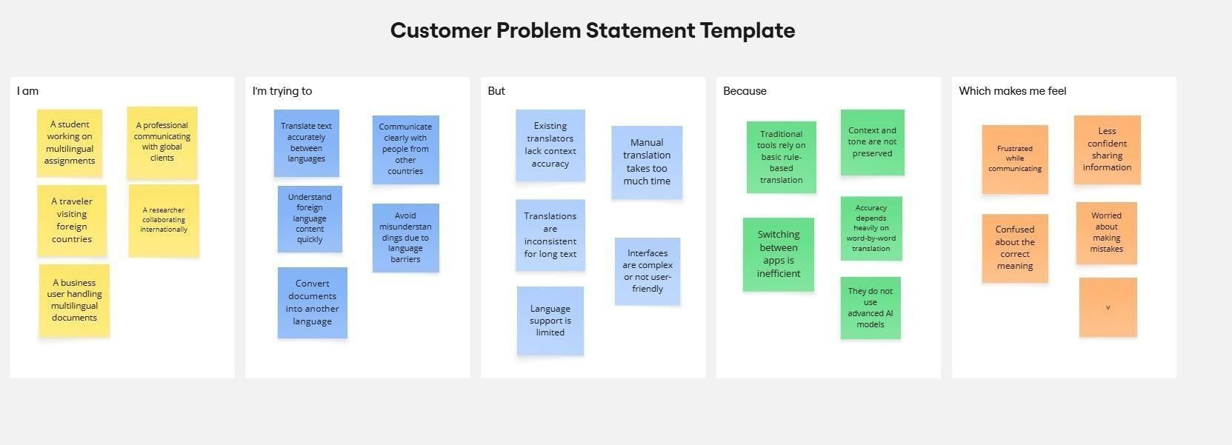

Problem  Statement  (PS) | I am (Customer) | I’m trying to | But | Because | Which makes  me feel
PS-1 | A student,  analyst, or nontechnical user working with databases | Retrieve information  from a  database using queries | Writing SQL  Queries require  technical expertise and correct syntax | I lack strong SQL knowledge and struggle to convert my questions into  SQL | Confused and dependent on technical assistance
PS-2 | A professional or business user handling large datasets | Access accurate data insights quickly for decision making | Manual SQL  query writing is time consuming and error prone | I frequently deal with complex queries and tight deadlines | Frustrated and less productive
PS-3 | A developer or  data professional | Interact with databases  efficiently using natural language | Traditional database tools do not support  intelligent query assistance | Existing  systems lack contextual understanding and automation | Limited by inefficiency and repetitive effort

Use Case Diagram

